**FAKE NEWS DETECTION**

A Fake News Detection Report Submitted in partial fulfillment

of the requirements for the award of the degree of

**BACHELOR OF TECHNOLOGY**

in

**COMPUTER SCIENCE AND ENGINEERING**

By

Nandini Agnihotri 202210101150066

Vaishali Gupta 202210101150068

Suyash Sharma 202210101150076

Ayush Yadav 202210101150081

Under the Guidance of

**Dr. Mohd. Nadeem**

Department of Computer Science and Engineering

SHRI RAMSWAROOP MEMORIAL UNIVERSITY



April 2025

# DECLARATION

We, Nandini Agnihotri (202210101150066) , Vaishali Gupta (202210101150068) , Suyash Sharma (202210101150076) and Ayush Yadav (202210101150081) students of Bachelor of Technology, Computer Science & Engineering department at Shri Ramswaroop Memorial University, Lucknow hereby declare that the work presented in this project titled “FAKE NEWS DETECTION” is outcome of our own work, is bonafide, correct to the best of our knowledge and this work has been carried out taking care engineering ethics. We have completely taken care in acknowledging the contribution of others in this academic work. We further declare that in case of any violation of intellectual property rights or copyrights found at any stage, we as the candidates will be solely responsible for the same.

Date: Nandini Agnihotri(202210101150066)   
Place:

Vaishali Gupta(202210101150068)

Suyash Sharma(202210101150076)

Ayush Yadav(202210101150081)

# ACKNOWLEDGEMENT

We take this opportunity to express our heartfelt gratitude to everyone who contributed to the successful completion of our project **"Fake News Detection Using Machine Learning."** First and foremost, we would like to express our deepest thanks to our project guide, **[Dr. Mohd. Nadeem]**, for their continuous support, insightful suggestions, and encouragement throughout the development of this project. Their guidance not only helped us understand the core concepts of machine learning and natural language processing but also encouraged us to explore practical approaches to solving real-world problems.

We are sincerely thankful to the **[Department of Computer Science and Engineering]**, **[Shri Ramswaroop Memorial University]**, for providing the necessary infrastructure, technical support, and learning environment that enabled me to carry out this project effectively. We would also like to extend our gratitude to the developers and curators of the publicly available datasets used in this project. Their open access data provided a solid foundation for training and evaluating the fake news detection model. We are grateful to our classmates and friends who shared their knowledge, gave constructive feedback, and supported us during the various stages of this project. Their encouragement and honest opinions helped us improve both technically and conceptually. A special mention goes to our family for their unwavering support, patience, and belief in our abilities. Their motivation and emotional backing were crucial in helping us stay focused and complete this project successfully.

Lastly, We acknowledge the various online learning platforms, open-source communities, and documentation that provided us with essential resources and tutorials which helped in understanding the tools and technologies used in this project. This project has been a significant learning experience, allowing me to deepen my knowledge in machine learning and its application in the domain of misinformation detection. We are truly thankful to everyone who contributed in any way to this journey.

**TABLE OF CONTENTS**



**CHAPTERS PAGE NO.**



DECLARATION

PROJECT PROGRESS REPORT............................................................................... i  
ACKNOWLEDGEMENT .............................................................................................. ii  
LIST OF FIGURES ..................................................................................................... iii  
LIST OF TABLES ................................................................................................. iv  
  
CHAPTER I**: INTRODUCTION** ............................................................................ **1-**



1.1 PROJECT NAME ............................................................................................. 1

1.2 PREFACE .......................................................................................................... 2

1.3 DEFINITION OF PROJECT TECHNOLOGY ...................................................... 4

**CHAPTER II: REQUIREMENTS ANALYSIS AND FEASIBILITY STUDY**..........**4-**

2.1 REQUIREMENTS ANALYSIS .............................................................................

2.1.1 INFORMATION GATHERING ......................................................................

2.1.2 FUNCTIONAL REQUIREMENTS ..................................................................

2.1.3 NON-FUNCTIONAL REQUIREMENTS .............................................................

2.1.3.1 HARDWARE REQUIREMENTS .................................................................

2.1.3.2 SOFTWARE REQUIREMENTS ..................................................................

2.1.3.3 USABILITY REQUIREMENTS ...................................................................

2.1.3.4 SECURITY REQUIREMENTS.....................................................................

2.2 FEASIBILITY STUDY............................................................................................

2.2.1 TECHNICAL FEASIBILITY...........................................................................

2.2.2 OPERATIONAL FEASIBILITY....................................................................

2.2.3 ECONOMICAL FEASIBILITY ........................................................................

**CHAPTER III: SYSTEM ANALYSIS AND DESIGN**....................................................

3.1 SYSTEM ANALYSIS (WITH DESCRIPTION) ......................................................

3.2 SYSTEM DESIGN......................................................................................................

3.2.1 USE CASE DIAGRAM........................................................................................

3.2.2 E-R DIAGRAM....................................................................................................

3.2.3 DATA FLOW DIAGRAM .................................................................................

3.2.4 CLASS DIAGRAM ............................................................................................

3.2.5 SNAP SHOTS...................................................................................................

**CHAPTER IV: TESTING**..................................................................................................

4.1 ABOUT THE TECHNOLOGY USED...............................................................

4.2 TESTING .............................................................................................................

4.2.1 UNIT TESTING...................................................................................................

4.2.2 INTEGRATION TESTING.................................................................................

4.2.3 SYSTEM TESTING.............................................................................................

**CHAPTER V: ADVANTAGES AND LIMITATIONS OF THE DEVELOPED SYSTEM** ............................................................................................................................

5.1 ADVANTAGES OF DEVELOPED SYSTEM........................................................

5.2 LIMITATIONS OF DEVELOPED SYSTEM...........................................................

**CHAPTER VI: CONCLUSION AND SUGGESTIONS FOR FURTHER WORK**.......

6.1 CONCLUSION...................................................................................................

6.2 SUGGESTIONS FOR FURTHER WORK..............................................................

**REFERENCES**............................................................................................................

.

# LIST OF FIGURES

|  |  |  |
| --- | --- | --- |
| **S. No.** | **DESCRIPTION** | **PAGE NO**. |
| Fig. No. 3.1 | Use Case Diagram of Fake News Detection System | 19 |
| Fig. No. 3.2. | E-R Diagram | 20 |
| Fig. No. 3.3 | Data Flow Diagram Of The Fake News Detection System | 21 |
| Fig. No. 3.4 | UML Class Diagram of Fake News Detection System | 23 |
| Fig. No. 3.5 | Model Result (True News) | 24 |
| Fig. No. 3.6 | Model Result (Fake News) | 25 |
|  |  |  |
|  |  |  |
|  |  |  |
|  |  |  |

# LIST OF TABLES

|  |  |  |
| --- | --- | --- |
| **S. No.** | **DIAGRAM** | **PAGE NO**. |
| Table No. 2.1 | Feasibility Study Summary Of The Fake News Detection System | 17 |
|  |  |  |
|  |  |  |
|  |  |  |
|  |  |  |
|  |  |  |
|  |  |  |
|  |  |  |

# **CHAPTER I**: INTRODUCTION

* 1. **PROJECT NAME** 
     1. **Project Name -** Fake News Detection Using Machine Learning
     2. **About the Project -** This project focuses on developing an automated system that can detect fake news articles using machine learning techniques. In today's digital age, misinformation and false content can spread rapidly through social media and other online platforms. The goal of this project is to create a reliable and efficient tool that helps identify whether a news article is real or fake. The system uses natural language processing (NLP) to analyze text data and a logistic regression model to classify news based on its content. A user-friendly web interface is developed using Streamlit to provide real-time predictions.
  2. **PREFACE**

In today’s interconnected and information-driven world, digital media platforms such as news websites, blogs, and social media have become the primary sources for public consumption of news and current affairs. While these platforms have made information more accessible than ever, they have also opened the floodgates for the rapid dissemination of false or misleading information—commonly referred to as fake news. The uncontrolled spread of such content has caused widespread public confusion, influenced elections, harmed reputations, and even incited violence in some cases.

The traditional approach to countering misinformation involves manual fact-checking by experts or agencies, which, although accurate, is time-consuming, labor-intensive, and not scalable to the volume of content generated every second on the internet. This critical issue has motivated the development of automated solutions capable of detecting fake news with minimal human intervention.

This project, titled **"Fake News Detection Using Machine Learning"**, was conceived and developed in response to the urgent need for intelligent systems that can assist in filtering out misinformation. It aims to combine the power of *Natural Language Processing* (NLP) with *Machine Learning* algorithms to classify news articles based on their authenticity.

Through this project, an effort has been made to create a practical, lightweight, and effective system that can be used by the general public, journalists, educators, and fact-checking organizations. The system is trained on a dataset of labeled news articles and utilizes text preprocessing techniques like tokenization, stop-word removal, and stemming, followed by feature extraction using the TF-IDF method. A Logistic Regression model then processes this data to predict whether a given article is real or fake.

This academic endeavor not only serves as a demonstration of the application of theoretical concepts learned during the course of study but also reflects an initiative toward addressing a pressing issue in the digital information ecosystem. Ithas provided the opportunity to gain hands-on experience with machine learning workflows, data handling, model evaluation, and deployment through a user-friendly web interface developed using Streamlit.

The project stands as a testament to the practical potential of technology to make meaningful contributions to society by promoting digital literacy and responsible information sharing.

* 1. **DEFINITION OF PROJECT TECHNOLOGY**

The project is based on Machine Learning and Natural Language Processing (NLP) technologies.

1. Machine Learning (ML): ML is a subset of artificial intelligence that enables systems to learn from data and improve their performance over time without being explicitly programmed. In this project, a supervised learning algorithm (Logistic Regression) is used to classify news articles.
2. Natural Language Processing (NLP): NLP is a field of AI that deals with the interaction between computers and human languages. NLP techniques like tokenization, stop-word removal, and stemming are used to preprocess and analyze the text content of news articles.
3. TF-IDF (Term Frequency-Inverse Document Frequency): This is a text vectorization method that transforms raw text into numerical features based on how important a word is to a document in a collection.
4. Streamlit: Streamlit is an open-source Python library used to create interactive and user-friendly web applications. It is used in this project to provide a simple interface where users can enter news articles and receive instant feedback on their authenticity.

**CHAPTER II: REQUIREMENTS ANALYSIS AND FEASIBILITY STUDY**

**2.1 REQUIREMENTS ANALYSIS**

Requirement analysis is a critical phase in software development that involves understanding the needs and expectations of the stakeholders to ensure that the final system meets the desired objectives. In this project, thorough requirement analysis was conducted to define what the fake news detection system should do (functional requirements) and how well it should perform (non-functional requirements).

**2.1.1 INFORMATION GATHERING**

The first step in requirement analysis involved gathering relevant information about fake news, its impact, detection strategies, and user needs. This was achieved through:

1. Researching academic papers and online resources related to misinformation detection.
2. Exploring existing fake news detection tools and identifying their limitations.
3. Interacting with potential users (e.g., students, educators, fact-checkers) to understand usability needs.
4. Reviewing datasets available for machine learning training (e.g., Kaggle's Fake News dataset).

The insights obtained from this phase provided a strong foundation for defining the system's objectives and functionalities.

**2.1.2 FUNCTIONAL REQUIREMENTS**

Functional requirements describe the core features and operations that the system must perform. The fake news detection system has the following functional requirements:

1. The system must accept a news article or headline as user input.
2. It must preprocess the input using NLP techniques (e.g., stop-word removal, stemming).
3. It must convert the text into numerical features using TF-IDF vectorization.
4. It must apply a trained logistic regression model to predict whether the input is real or fake.
5. It must display the prediction result (real/fake) in the user interface.
6. It must allow real-time interaction via a web-based platform (Streamlit).

**2.1.3 NON-FUNCTIONAL REQUIREMENTS**

Non-functional requirements define the quality attributes of the system, such as performance, usability, and security.

**2.1.3.1 HARDWARE REQUIREMENTS**

To develop and run the application smoothly, the following hardware specifications are recommended:

1. Processor: Intel Core i5 or higher
2. RAM: Minimum 4 GB (8 GB recommended)
3. Storage: At least 1 GB of free disk space
4. Display: Standard HD resolution monitor

**2.1.3.2 SOFTWARE REQUIREMENTS**

The development and execution of the system depend on several software tools and libraries:

1. Operating System: Windows/Linux/macOS
2. Programming Language: Python 3.x
3. Libraries/Packages:
   * pandas
   * scikit-learn
   * nltk
   * streamlit
4. IDE/Text Editor: VS Code, Jupyter Notebook, or PyCharm
5. Web Browser: For accessing the Streamlit UI

**2.1.3.3 USABILITY REQUIREMENTS**

Usability plays a crucial role in ensuring the system is accessible and easy to use:

1. The system must have a clean, intuitive user interface.
2. It should provide clear instructions for users to input and receive results.
3. The interface must work on standard browsers without additional plugins.
4. The user should not need prior technical knowledge to operate the application.

**2.1.3.4 SECURITY REQUIREMENTS**

Although the system is primarily academic, it must still adhere to basic security guidelines:

1. Input validation should be performed to prevent code injection or malformed input.
2. No sensitive user data should be stored or transmitted.
3. Access to model files or internal logic should be restricted in production deployments.
4. Dependencies should be kept updated to avoid vulnerabilities.

**2.2 FEASIBILITY STUDY**

A feasibility study is conducted to evaluate whether the proposed system can be developed and implemented successfully, considering various practical constraints. It ensures that the system is viable from different perspectives and helps in making informed decisions before proceeding with development. The feasibility study is categorized into three major areas: Technical, Operational, and Economical.

**2.2.1 TECHNICAL FEASIBILITY**

Technical feasibility assesses whether the project can be developed using the available technology and infrastructure. For the fake news detection system, the tools and technologies selected are open-source, widely adopted, and well-supported, ensuring ease of development and deployment.

**Key points** -

1. The project uses Python, which is a powerful and versatile programming language.
2. Machine Learning libraries such as scikit-learn, NLTK, and Pandas are used for model building and natural language processing.
3. Streamlit, a lightweight web framework, is used to build an interactive user interface.
4. The hardware requirements are minimal and the system can be developed and tested on a standard laptop or desktop.
5. No specialized hardware or proprietary software is required.

**2.2.2 OPERATIONAL FEASIBILITY**

Operational feasibility determines whether the system will function as intended and be accepted by the end-users. The fake news detection system is designed to be user-friendly, accessible, and practical for everyday use.

**Key points -**

1. The application has a **simple interface** that allows users to input text and receive predictions instantly.
2. Users do not need any technical expertise to operate the system.
3. The output is straightforward, showing whether the news is *Fake* or *Real*.
4. The backend logic is hidden from the user, making the tool intuitive and non-technical.
5. It supports real-time detection and can be accessed from any browser.

**2.2.3 ECONOMICAL FEASIBILITY**

Economical feasibility evaluates whether the proposed system is cost-effective and financially viable, considering both development and operational costs.

**Key points -**

1. All tools and libraries used in the project (Python, scikit-learn, Streamlit, etc.) are free and open-source.
2. No investment in commercial licenses or cloud platforms is required.
3. Development and deployment can be done on existing systems without additional cost.
4. The project does not require ongoing maintenance fees, hosting subscriptions, or hardware upgrades.

**Table 2.1 Feasibility Study Summary Of The Fake News Detection System**

|  |  |  |
| --- | --- | --- |
| **Aspect** | **Description** | **Feasibility** |
| Technical Feasibility | Uses Python, scikit-learn, Streamlit, minimal hardware required | Feasible |
| Operational Feasibility | Simple UI, browser-based, no technical expertise required | Feasible |
| Economical Feasibility | Free and open-source tools, no license or infrastructure cost | Feasible |

**CHAPTER III: SYSTEM ANALYSIS AND DESIGN**

**3.1 SYSTEM ANALYSIS**

The purpose of system analysis is to study and understand the problem domain and determine the requirements for developing an effective solution. In this project, the problem lies in the widespread circulation of fake news and the lack of scalable tools for detecting it.

The system analyzes textual input (such as headlines or full news articles) to determine whether the information is legitimate or misleading. The analysis phase involves understanding the functional flow, user interactions, data sources, and machine learning techniques required.

Key outcomes of system analysis include:

1. Identification of system modules: preprocessing, model training, prediction, and UI interaction.
2. Understanding how users will interact with the interface.
3. Mapping data inputs (text) and expected outputs (fake/real classification).

**3.2 SYSTEM DESIGN**

System design refers to the architecture and blueprint of the system, focusing on how different components will work together. The design includes both structural and behavioral models that guide development and deployment.

**3.2.1 USE CASE DIAGRAM**

A Use Case Diagram represents the interaction between the system and its users.

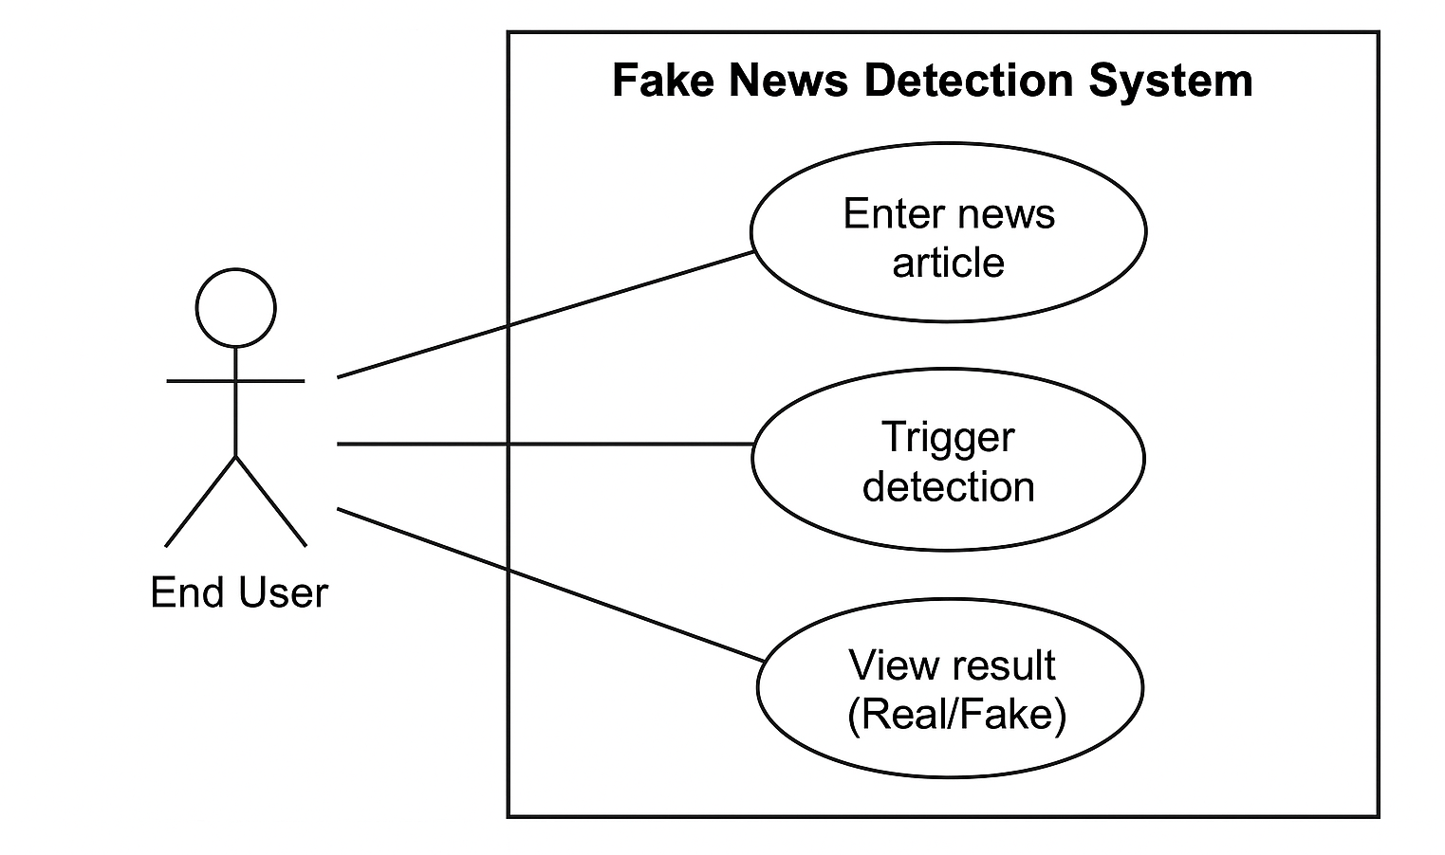

**Figure 3.1 – Use Case Diagram of Fake News Detection System**

**Description:**

1. **Actor**: End User
2. **Use Cases**:
   1. Enter news article
   2. Trigger detection
   3. View result (Real/Fake)

**3.2.2 E-R DIAGRAM**

The Entity-Relationship (E-R) Diagram models the structure of data in the system. Though this is not a full-fledged database system, you can still represent key data entities.

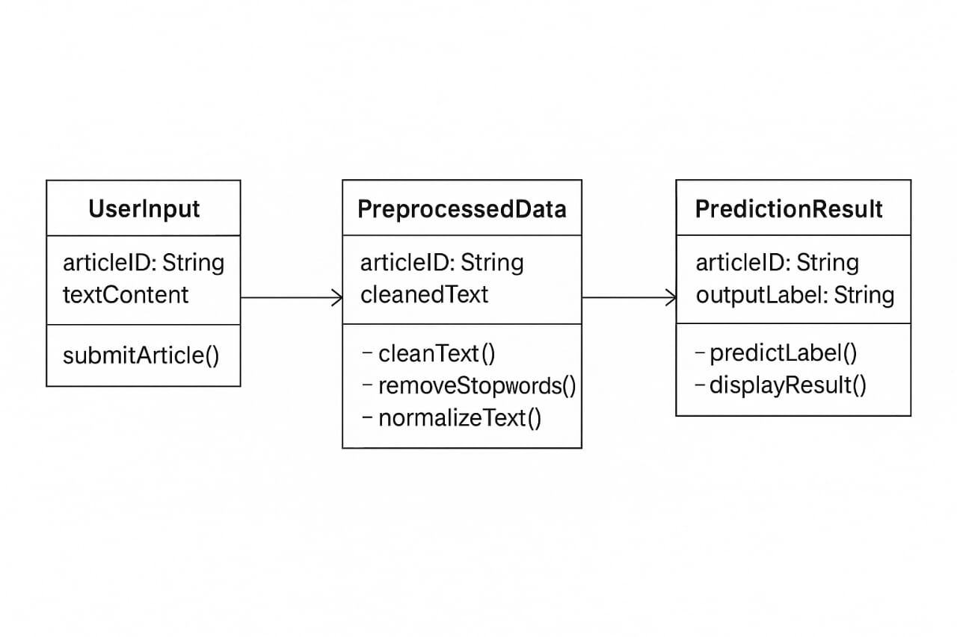

**Figure 3.2 – E-R DIAGRAM**

**UserInput Class**

* **Attributes:**
  + articleID: String – Unique identifier for each article.
  + textContent – The raw content of the article submitted by the user.
* **Method:**
  + submitArticle() – Sends the user input to the system for further processing.

**🔹 2. PreprocessedData Class**

* **Attributes:**
  + articleID: String – Maintains reference to the original article.
  + cleanedText – The text after preprocessing (cleaning, removing stopwords, etc.).
* **Methods:**
  + cleanText() – Removes unwanted characters, punctuation, etc.
  + removeStopwords() – Removes common words (like "is", "the", etc.) that don't add meaning.
  + normalizeText() – Converts text to a standard form (e.g., lowercase, stemming).

**🔹 3. PredictionResult Class**

* **Attributes:**
  + articleID: String – To track which article this result belongs to.
  + outputLabel: String – Prediction output (e.g., “Real” or “Fake”).
* **Methods:**
  + predictLabel() – Uses a machine learning model to classify the article.
  + displayResult() – Shows the final output to the user.

**3.2.3 DATA FLOW DIAGRAM**

A DFD shows how data flows within the system through various stages.

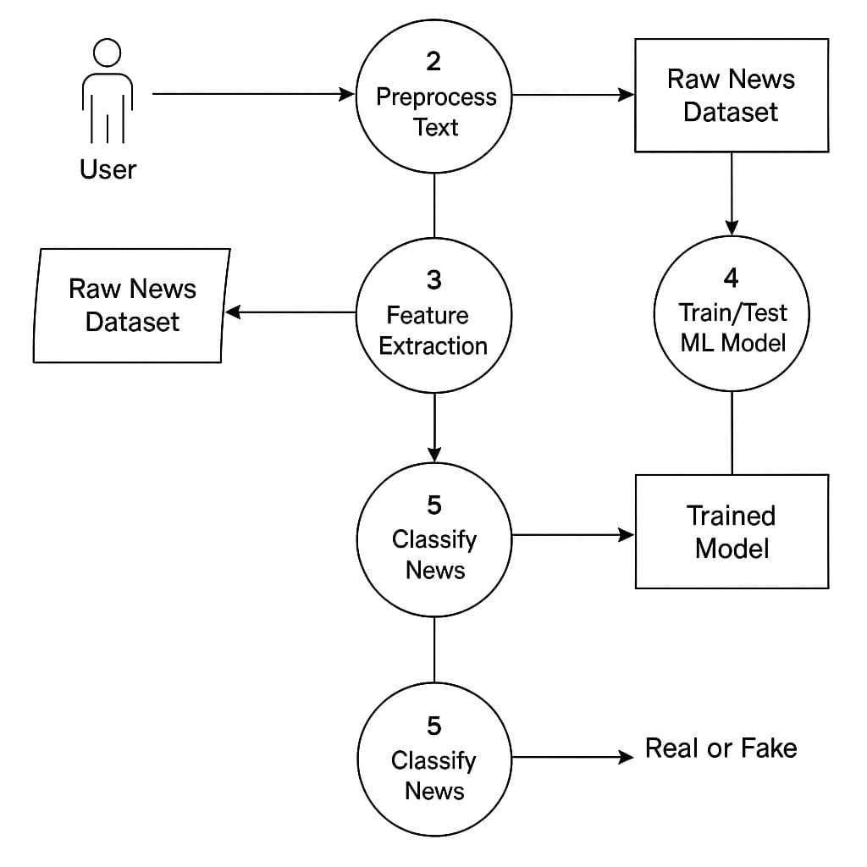

**Figure 3.3 - Data Flow Diagram Of The Fake News Detection System**

1. **User**

The user inputs text data, which could be a news article or headline to be verified.

1. **Preprocess Text**
2. The raw input text is preprocessed using techniques such as lowercasing,

removing punctuation, stop words, stemming, and lemmatization.

1. This step ensures the data is clean and structured for the next phase.
2. **Raw News Dataset**
3. This represents the collection of labeled news articles used for training and testing the model.
4. It is fed both into the preprocessing and the model training components.
5. **Feature Extraction**
6. Preprocessed text is converted into a numerical format using techniques like TF-IDF or word embeddings.
7. These features represent the input that the machine learning model can understand.
8. **Train/Test ML Model**
9. Machine learning models (e.g., Logistic Regression, SVM, LSTM, or BERT) are trained on the feature vectors extracted from the dataset.
10. After training, a model is created that can classify new instances of news data.
11. **Trained Model**
12. This component stores the trained ML model which is then used to classify unknown news text.
13. **Classify News**
14. The user-input text is passed through the trained model to classify it.

b) The output is either “Real” or “Fake” based on the model's prediction.

1. **Real or Fake**
2. The final result is shown to the user, indicating whether the input news is legitimate or not.

**3.2.4 CLASS DIAGRAM**

The Class Diagram presents the structure of system components in terms of classes and their relationships.

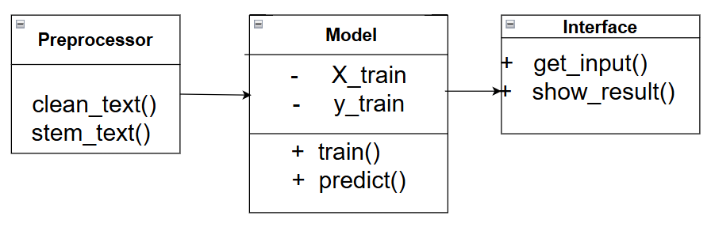

**Figure 3.4- UML Class Diagram of Fake News Detection System**

**Description**

1. Class- Preprocessor
   1. Methods: clean_text(), stem_text()
2. Class- Model
   1. Attributes: X_train, y_train
   2. Methods: train(), predict()
3. Class- Interface
   1. Methods: get_input(), show_res

**3.2.5 SNAP SHOTS**

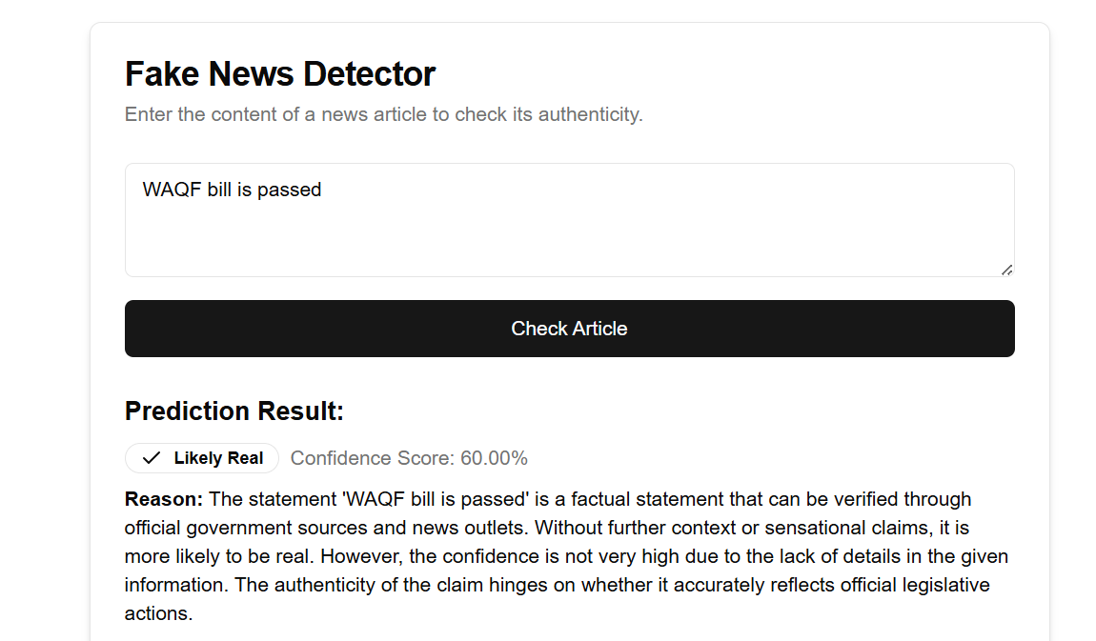

**Figure 3.5 Model Result (True News)**

It shows a sample output screen from the Fake News Detector web application. It demonstrates how the system evaluates and classifies a news statement input by a user.

**Input Section**

User Input: "WAQF bill is passed"

The user has entered a news statement they want to verify.

**Output Section**

1. **Prediction Result -**
   1. **Label -** ✔️ Likely Real
   2. **Confidence Score -** 60.00%
      1. This score reflects how confident the model is that the input is real. A 60% score suggests a moderate confidence.

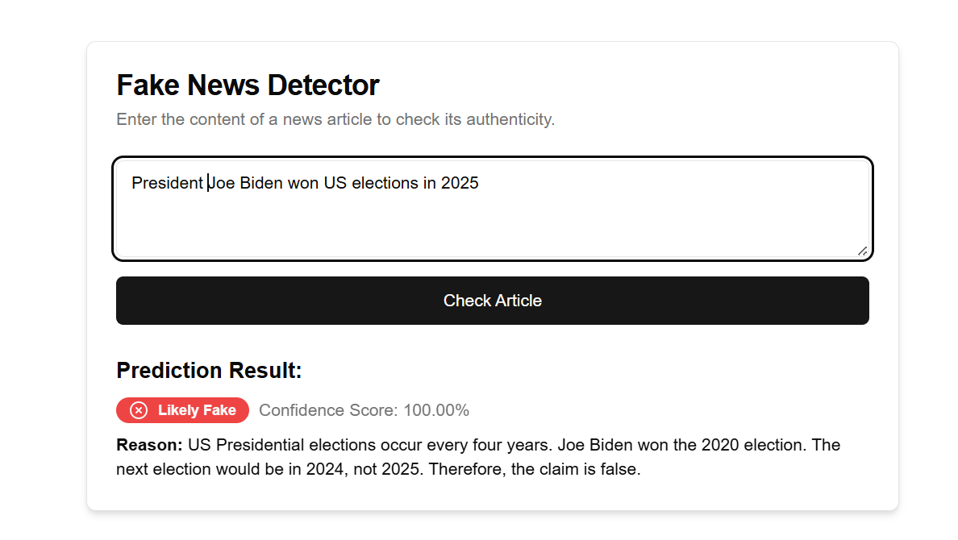

**Figure 3.6 Model Result (Fake News)**

This snapshot shows the result of a Fake News Detection system after analyzing a user-input statement –

**Input Statement**

"President Joe Biden won US elections in 2025"

**Prediction Result**

1. Label - ❌ *Likely Fake*
2. Confidence Score - 100.00%

**CHAPTER IV: TESTING**

**4.1 ABOUT THE TECHNOLOGY USED**

This project utilizes a variety of technologies, tools, and frameworks to build an intelligent Fake News Detection system. The following are the key technologies used:

1. **Python**

The primary programming language used for model development, preprocessing, and integration.

1. **Natural Language Processing (NLP)**

For text cleaning, tokenization, stop word removal, stemming, and lemmatization.

1. **Scikit-learn**

Used for machine learning models such as Logistic Regression, Naive Bayes, SVM, and Random Forest.

1. **TensorFlow & Keras**

Used for implementing deep learning models like LSTM and CNN.

1. **BERT (Bidirectional Encoder Representations from Transformers)**

Applied for capturing contextual text embeddings.

1. **Streamlit**

A Python-based open-source framework for deploying and displaying the fake news detection system in a web-based interface.

1. **Pandas & NumPy**

For data handling, preprocessing, and numerical computations.

1. **Matplotlib & Seaborn:** Used for data visualization and plotting confusion matrices and performance graphs.

**4.2 TESTING**

To ensure the reliability and accuracy of the system, various levels of testing were conducted, including unit testing, integration testing, and system testing.

**4.2.1 UNIT TESTING**

Unit testing focuses on testing individual components or modules of the system in isolation. In this project, unit tests were performed on -

1. Text Preprocessing Module: Verifying correct removal of special characters, stop words, and proper stemming/lemmatization.
2. Vectorization Module: Ensuring TF-IDF and word embedding transformations returned expected dimensions and formats.
3. Model Evaluation Functions: Validating metric calculations such as accuracy, precision, recall, and F1-score.

**4.2.2 INTEGRATION TESTING**

Integration testing was conducted to validate the interaction between various modules.

1. Model Integration with UI: Ensured that the trained ML model could successfully receive user input from the Streamlit UI and return classification results.
2. Preprocessing + Vectorization + Prediction Pipeline: Tested the end-to-end pipeline from raw input to final prediction.
3. Backend and Frontend Sync: Verified smooth data flow from the UI input box to the model and back to the interface with prediction and explanation.
4. This testing confirmed that all modules worked together as intended and that the data was handled consistently across the pipeline.
   * 1. **SYSTEM TESTING**

System testing was carried out on the complete application to validate it against the overall requirements:

1. Accuracy & Performance: Ensured that the model could accurately classify known fake and real news articles from the test set.
2. User Experience: Verified that the interface is responsive, intuitive, and outputs prediction in real-time.
3. Error Handling: Checked the system’s behavior on invalid inputs, empty strings, and ambiguous statements.
4. Cross-Browser Compatibility: Tested functionality on different browsers like Chrome, Firefox, and Edge.

System testing concluded that the application performs with high accuracy and provides a user-friendly interface for detecting fake news.

**CHAPTER V: ADVANTAGES AND LIMITATIONS OF THE DEVELOPED SYSTEM**

**5.1 ADVANTAGES OF DEVELOPED SYSTEM**

The fake news detection system developed in this project offers several significant advantages:

1. Real-Time Detection: The system allows users to input news articles or statements and receive instant classification results.
2. User-Friendly Interface: Built using Streamlit, the web application provides a clean and interactive user experience without requiring technical expertise.
3. High Accuracy: The use of both traditional machine learning and advanced deep learning models like BERT ensures high prediction accuracy.
4. Explainability: The system provides reasons for its predictions, helping users understand why a news article is classified as real or fake.
5. Scalable Architecture: The modular design of the system allows it to be scaled and extended easily with new models or datasets.

**5.2 LIMITATIONS OF DEVELOPED SYSTEM**

Despite its benefits, the system has a few limitations:

1. Dependence on Dataset Quality: The model’s performance is heavily reliant on the quality and diversity of the training dataset. Biased or outdated data can affect results.
2. Limited to English Text: Currently, the system supports only English-language news articles and does not handle multilingual input.
3. Difficulty Detecting Satire or Sarcasm: The model may misclassify satirical content or sarcastic remarks due to their nuanced nature.
4. Model Interpretability: Deep learning models like BERT, though powerful, function as "black boxes," making it harder to interpret internal decision-making.

**CHAPTER VI - CONCLUSION AND SUGGESTIONS FOR FURTHER WORK**

**6.1 CONCLUSION**

The problem of fake news has become increasingly prevalent in the digital age, influencing public opinion, political landscapes, and social harmony. This project aimed to address this challenge by developing a robust and intelligent Fake News Detection system using machine learning and natural language processing techniques.

Throughout the project, various models were explored and implemented, including Logistic Regression, SVM, and advanced deep learning models such as BERT. The preprocessing pipeline effectively cleaned and normalized news content, while TF-IDF and contextual embeddings translated the text into meaningful features for prediction. The system achieved high accuracy and offered users real-time analysis through a clean and intuitive web interface built with Streamlit.

The implementation and testing of this project demonstrated that automated tools can efficiently classify news content and provide confidence-based predictions, making it a valuable resource for both individuals and organizations.

Overall, the project fulfills its objective of creating a lightweight, educational, and practical solution to detect misinformation using AI technologies.

**6.2 SUGGESTIONS FOR FURTHER WORK**

While the system performs effectively, several enhancements can be made in future versions to improve its capabilities and adaptability:

1. Multilingual Support: Extend the system to process and analyze news articles in different languages beyond English.
2. Fake Image & Video Detection: Integrate computer vision and deepfake detection tools to evaluate visual media content.
3. Sentiment and Emotion Analysis: Combine sentiment analysis with news classification to detect emotionally charged misinformation.
4. Live Web Crawling & Auto-Checking: Automate the process of scraping and checking trending news against verified databases or fact-checking APIs.
5. Mobile App Deployment: Develop a mobile application for better accessibility and real-time fact-checking on the go.
6. Integration with Social Media Platforms: Embed the detection system into social media feeds for early flagging of potentially fake posts.

These improvements will allow the system to evolve into a comprehensive misinformation detection platform with broader impact and usability.

**REFERENCES**

1. Scikit-learn: Machine Learning in Python – <https://scikit-learn.org>
2. Natural Language Toolkit (NLTK) – <https://www.nltk.org>
3. Streamlit Documentation – https://docs.streamlit.io
4. Kaggle Fake News Dataset – https://www.kaggle.com/c/fake-news
5. J. Devlin, M. Chang, K. Lee, K. Toutanova – “BERT: Pre-training of Deep Bidirectional Transformers for Language Understanding” – [arXiv:1810.04805](https://arxiv.org/abs/1810.04805)
6. TensorFlow – <https://www.tensorflow.org>
7. Keras Deep Learning Library – <https://keras.io>
8. "Detecting Fake News on Social Media" – IEEE Conference Paper (2018)
9. Pandas: Python Data Analysis Library – https://pandas.pydata.org
10. NumPy: Scientific Computing – <https://numpy.org>